Assignment 12.1:

Follow the below link document steps to download and import Acadgild Spark VM in the Oracle Virtual Box.

* Downloaded and imported spark ova

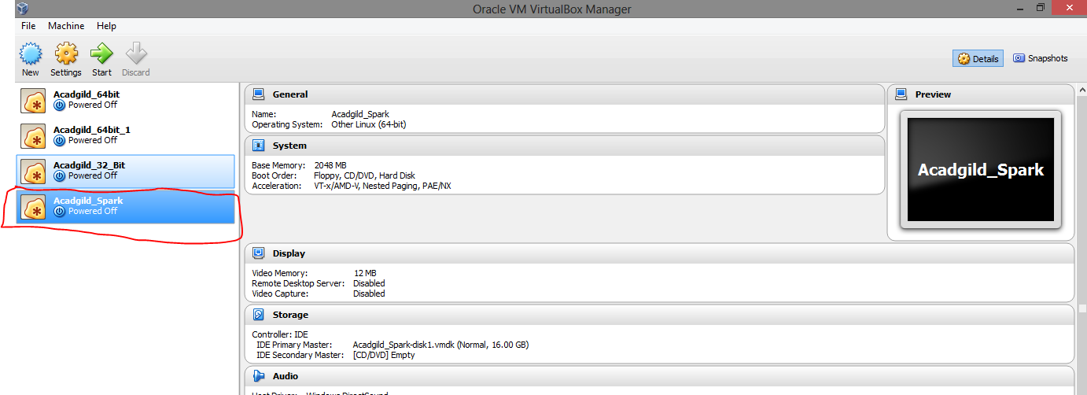

* Open the terminal and type the command jps to check the list of daemons, we need to start all the daemons for the first time.

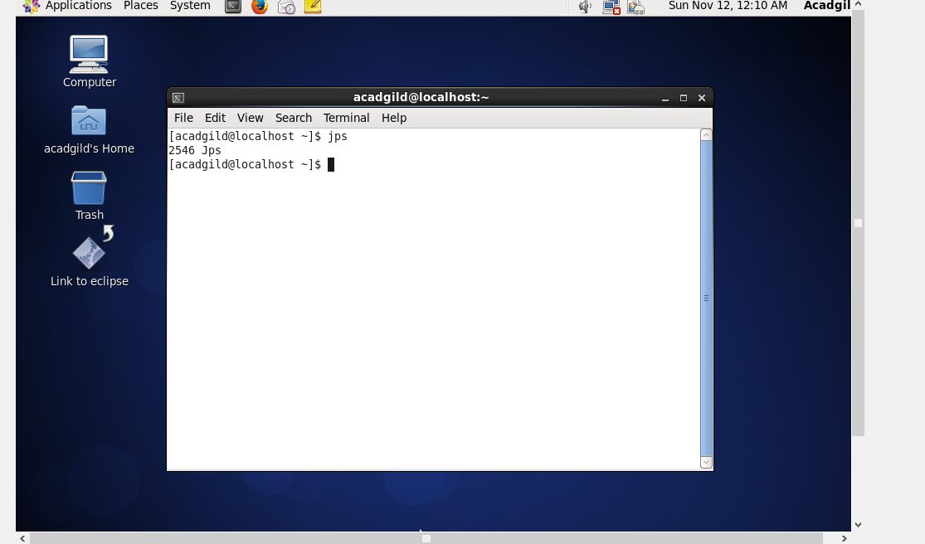

Start all the services:

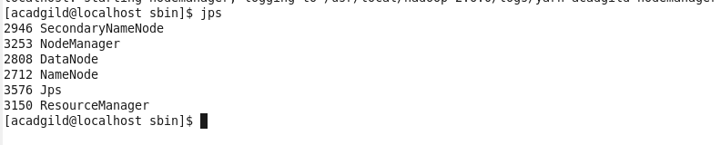

Starting Spark daemons Master,Workers Move into the sbin folder of spark installed directory(Here spark is installed in /usr/local/spark/ directory.)

Starting Master:

Command: ./ start-master.sh

Starting Slaves:

Command: ./start-slaves.sh

